**ERRORS & SOLUTIONS**

**“Error”**

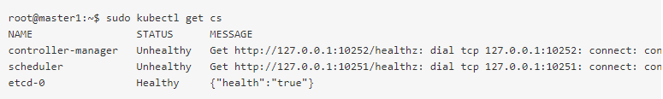

**Solution Link:** <https://my.oschina.net/u/4408611/blog/4660483>

**Solution steps:**

**Step 01:** Check the following files exit or not: by this command

ls /etc/kubernetes/manifests/

**Output should be**



**Step 02:**  Run the command and remove the port=0 line

vim /etc/kubernetes/manifests/kube-controller-manager.yaml

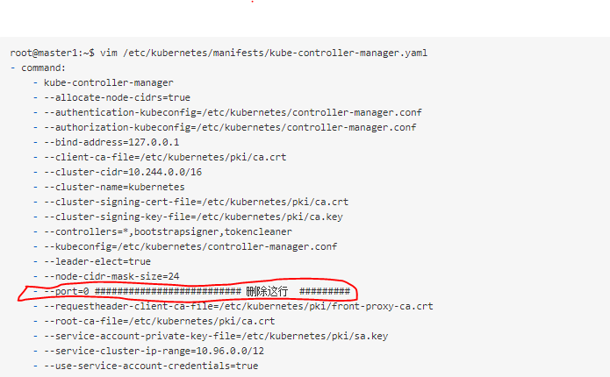

**Step 03:** Run the command and remove the port=0 line again from

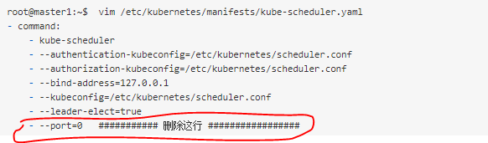

**Step 04:** Restart the kubelet by given command

systemctl restart kubelet

*Now Everything will be OK,*

